The million pines hunt club
News
Holiday edition 2017
It is the time of year that things are feeling different. Things are going on sale, GUNS, CAMO, and STANDS which we all can ask Santa for. The hunting season has a great start and our club is the greatest it has ever been and the members of our club make it the greatest.
It is a great time to spread joy and fun to all. Some our members will be celebrating Thanksgiving at the camp with their families which looks like it’s going to turn into an annual tradition.
Happy Holidays to all. May all your wishes come true and you are blessed with good health and prosperity.
If you have any more room on your walls these are some suggestions
for your holiday decorations.

Dear Santa
WE ARE MILLION PINES HUNT CLUB:

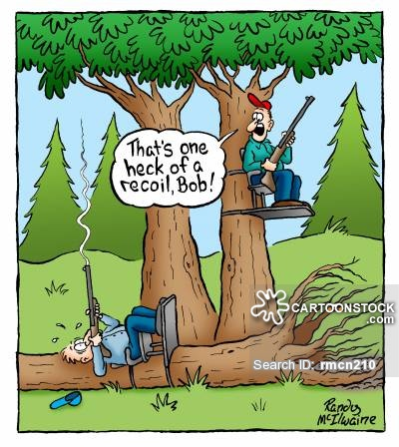 the hazard of reloading while drinking.

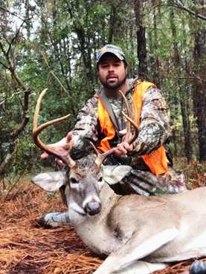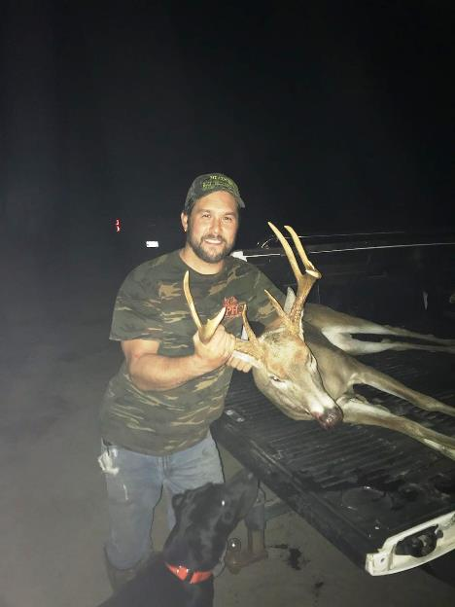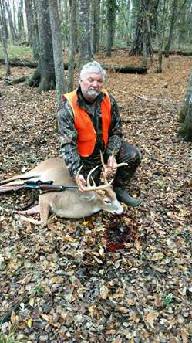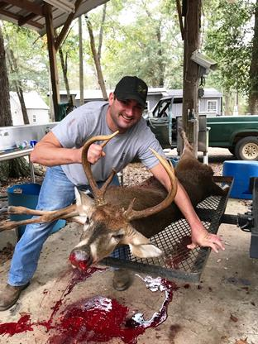
Congratulations guys you have some fine looking bucks.

As the 2017- 2018 season progresses the kill log is showing that we are in for another great harvest year. We have had a lot of nice bucks and does killed. We have had a few FINE $ deer shot but from what I can see and the members I’ve spoken with agree, the second look through the scope and not pulling the trigger too quick is paying off. Keep your money and let the little ones grow big.

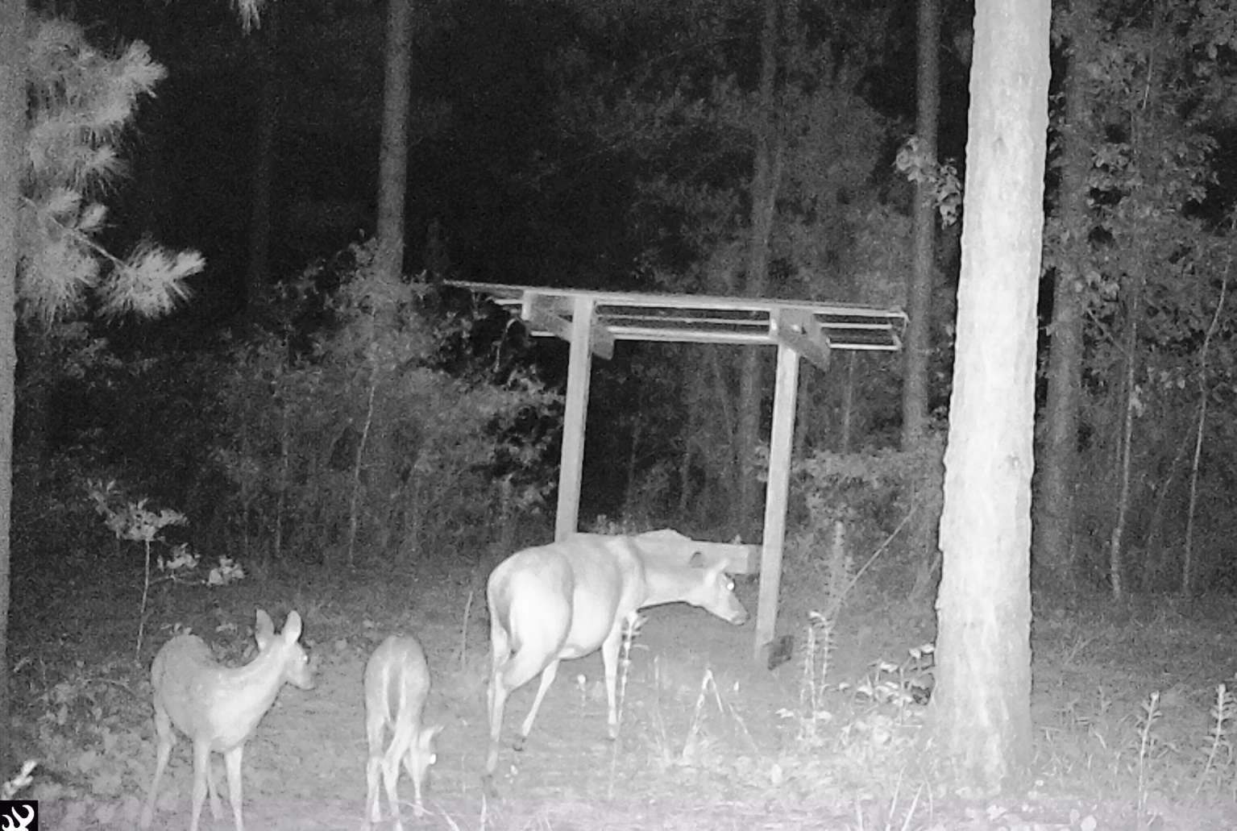

If you really want to get the jolly old man’s attention at your camp you may want to do something like this for the holidays.

I’m sure Santa will be visiting your camp.

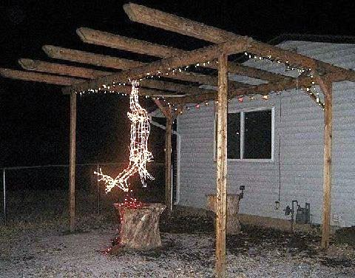

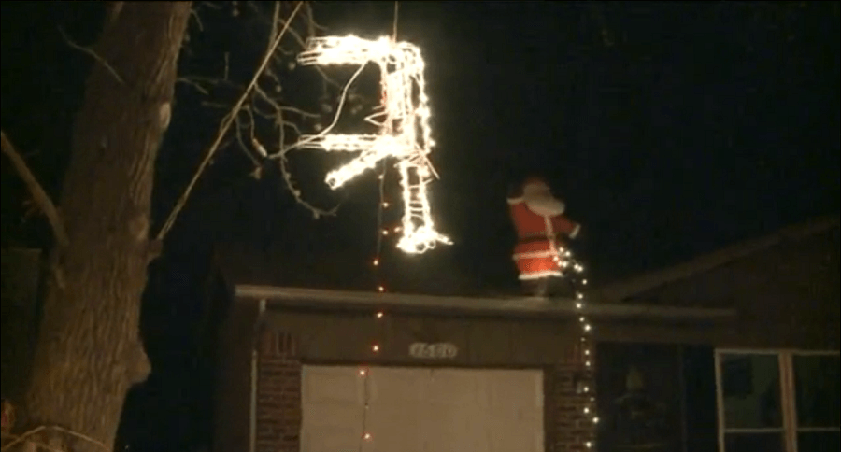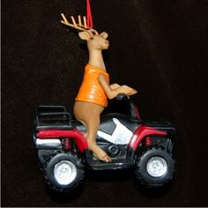

THIS IS A SECOND REMINDER OF WHAT CAN HAPPEN IF YOU DO NOT DRAIN YOUR WATER.
PLEASE CHECK WITH YOUR FELLOW MEMBER S ON THE CLUB AREAS THAT NEED DRAINING.
EXAMPLE S ARE THE CLUB HOUSE, BATH HOUSE, AND THE ICE MACHINE FILTER. IT MUST BE DRAINED OR IT WILL BREAK AND NO WATER WILL GO TO THE ICE MACHINE.
IF YOU ARE THE LAST ONE TO LEAVE CAMP PLEASE CHECK THE ABOVE. YOU ARE RESPONSIABLE FOR MAKING SURE ALL IS SECURE.

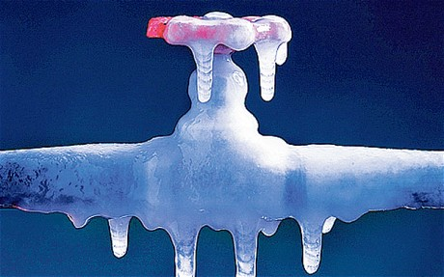

Winter is on the way and I know it is hard to believe that this may happen. Now is the time to make sure you will come back to your camp and not be flooded or no water due to frozen pipes or valves.
Take a little time between hunts and check the following it will be worth your time.

1) Make sure you have a low point drain to drain all your water pipes: A low point drain is a drain at the lowest point of your camp.
2) When you leave your camp turn off your main water valve to your camp. Then open your low point water drain and open all the faucets in your camp hot and cold water. Don’t forget your shower. Flush your toilet and add a little anti-freeze to the bowl and tank.

Remember if you leave water in your pipes it will freeze and freeze up your water valves.
If you don’t have a main to your camp and only your camp please put one in. If you don’t have a low point drain please put one in.
Important news from the officers’ corner:
The following email was sent out by Tryon, MPHC president, on some items that needed to be addressed. If you did not receive it or just failed to read it I am putting it in this section for your benefit.

Good morning members,
It looks like we are off to a great season. A lot of deer have been harvested even with the weather being as warm as it has been.

I have some very important things that have come to my attention through discussions with fellow officers, who you have talked with, that need to be addressed at this time. These are very important.

Please be advised that if you shoot a deer and leave it in the woods to avoid a fine it is a direct violation of our club rules resulting in direct AT THAT TIME termination of your membership on the spot and no refund of dues. You are NOT the type of club member who deserves to be a part of MPHC—there will be no discussion or reasons will even come into play. An act such as this is a disgrace of honesty to the club and has no excuse. You are deceiving the club and its members. Be a man, bring the deer in and face the music. It’s a lot better and the fine can be worked out.

The other thing that has come to my attention is the ruling on the 4 bucks that have been harvested in the past weeks. As you have discussed with some of your officers, has a determination of legality been made? After reviewing the pictures to determine age and then taking the weight into consideration, along with the fact that the members who shot these deer are going to have them mounted as trophy deer, it was said and agreed by 3 officers excluding the officers who shot the deer, that there are no fines. The answer to your question is yes. All four of the bucks harvested will be legal, due to maturity of the animals.

It is a great thing that you have five officers to discuss things with and is also great that you exercise a one-on-one talk. Always remember that a Rumor is a word that is defined as “unsubstantiated information of uncertain origin spared by talk HEARSAY”. A rumor never needs to get started. If you are not satisfied with something call me.
Tryon Huggins 770 318-1382
Thanks for your continued support.

As your Vice President of MPHC I would like say and keep saying.
We have the best club we have ever had. Our members are the best we have ever had and that is because we all are aware of what a rumor can turn into. Unless you hear it from an officer who you elected to run our club it is no more than a rumor and needs to be trashed.
We are here to answer your questions and take all your suggestions into view. Keep up the great work of disregarding any rumors.

Thanks for your support.
Some rules to remember:
1- Always practice safety.
2- Always sign out to what track you will be hunting.
3- Obey all club rules which have been put in effect for your wellbeing.
4- Be courteous to fellow member.
5- As always our club is not divided into two groups of members. We are one club and one membership showing respect to all.
6- Last, but not least HAVE FUN AND ENJOY EVERY MINUTE YOU ARE IN THE WOODS.

GUY
I wish each and every one of our members and their families a HAPPY THANKSGIVING and the greatest of the upcoming HOLIDAYS.

I will see you at the camp soon.

THE HUNTER IN THIS PICTURES LOOSES MORE DEER THAN YOU COULD EVERY BELEAVE, BUT WE LOVE HIM.

